Tshangkhar Shingmen Detshen Non-wood Forest Products Management and Marketing Group Plan (1st Revision)
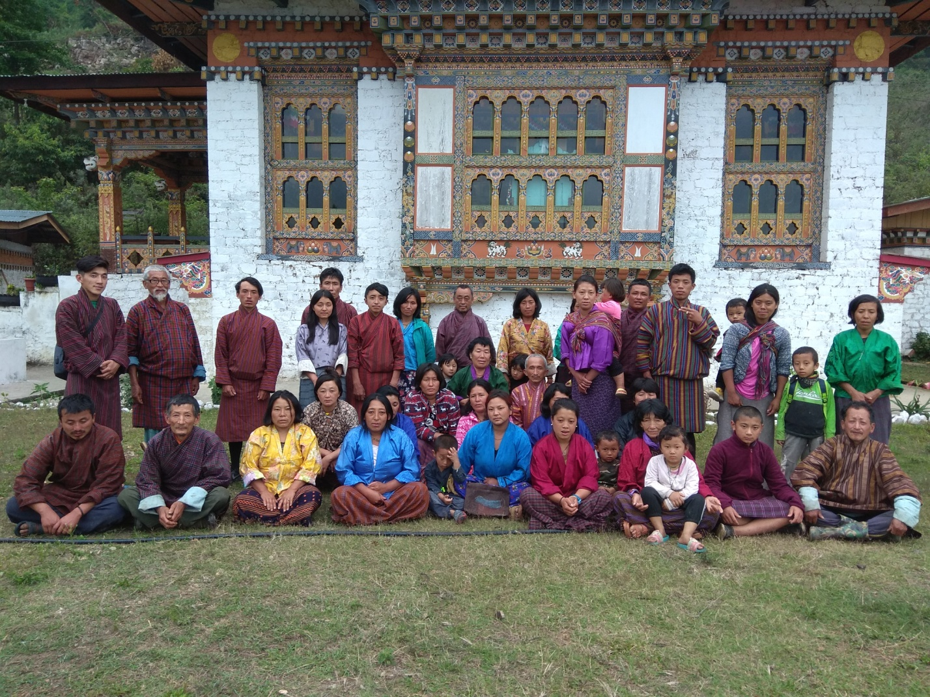
Drepong Gewog, Mongar Dzongkhag
Plan Period: 2021-2026

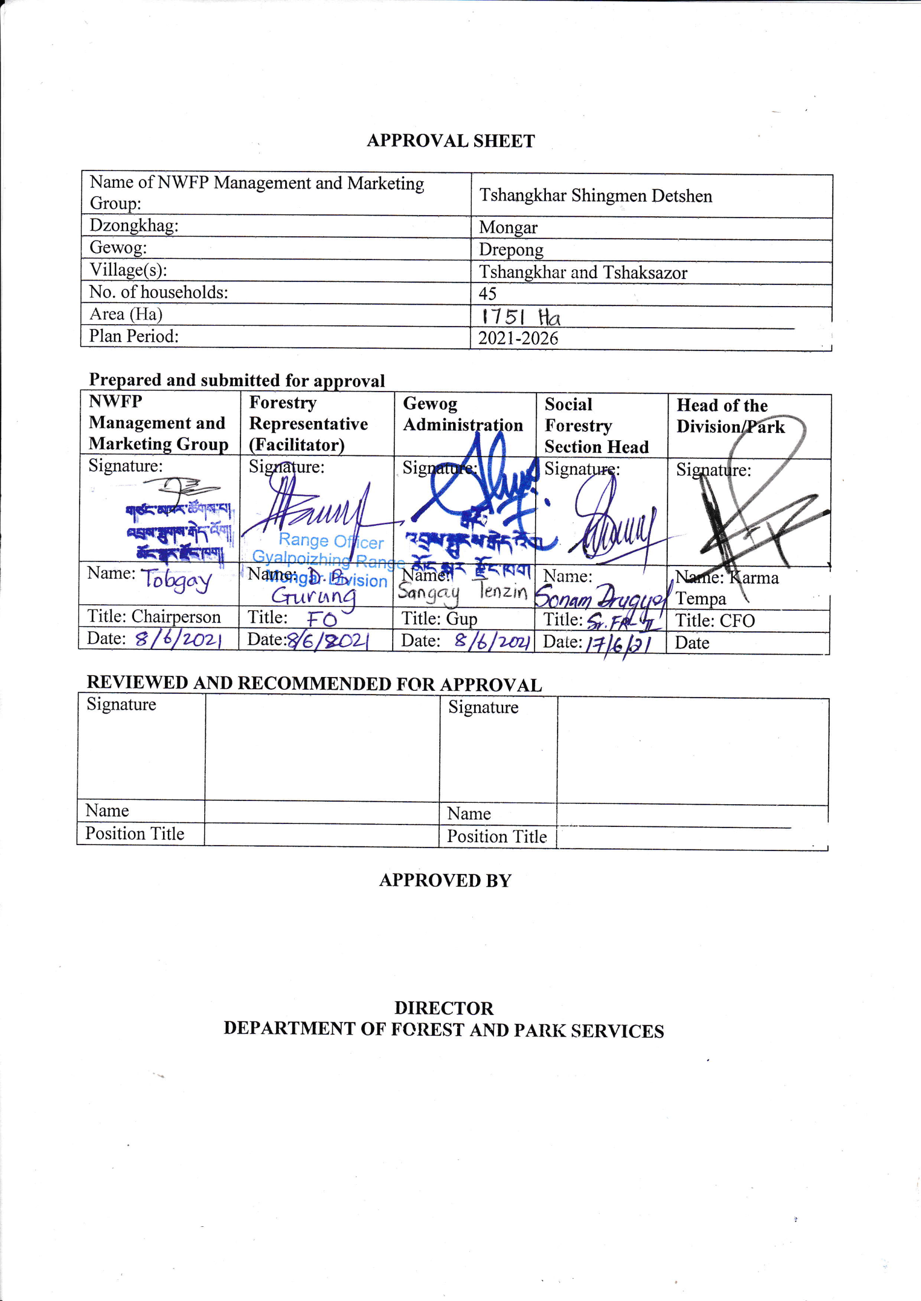
PPROVAL SHEET

Table of Contents
PART A: NWFP Management and Marketing Plan 1
1. Introduction 1
2. Goals and objectives: 2
Achievements of the Past Plan 2
3. Description of NWFPs: 3
4. Harvesting prescriptions for sustainable NWFP harvesting 4
5. Marketing and sales plan 8
6. Marketing arrangements 9
7. Benefits to the members 9
8. Benefits to the group 10
PART B: By-laws: Group regulations and norms 11
1. Members of the NWFP management & marketing group 11
2. Executive Members 12
2.1 Chairperson 12
2.2 Secretary 12
2.3 Treasurer 13
3. Compensation to the executive committee for marketing 13
4. Membership fee and purpose 13
5. Community development fund and utilization of fund 13
6. New Membership 14
7. Resignations of Members 14
8. Conflict resolution 14
9. Penalties 14
10. Authority of the Department 15
11. Cancellation of NWFP Management Certificate 15
12. Annexures 16
Annexure I: NWFP Group Membership List 16
Annexure II: List of NWFPs to be collected by the group member 18

PART A: NWFP Management and Marketing Plan

Introduction
Tsangkhar village falls under Drepong Geog, Mongar Dzongkhag and has 30 households. It is connected with 11 km farm road from Gyalpozhing–Nganglam highway. The village is bordered by Chaksazor to the East, Yongri to the West, Zunglen to the North and Gyalpoizhing to the South. The current plan has included 13 additional members from Chaksazor village in the same Chiwog adding a total member to 45 households. Tsangkhar Amla group was initially formed in the year 2011 by 18 interested households for a period of 3 years. However, the group remained dormant for several years and the members came together to revive the group again in 2020 as there are potential for other NWFPs that can be collected and sold for income generation. Also, to revive lemongrass oil distillation and there is a scope for organic oil production from Diploknema butyracea which existed in those days.

The designated NWFP collection area lies around the settlements and fall within the boundary extent of 1751 hectares, however the actual collection area with available resources are limited to smaller blocks within the boundary. The management plan covers 11 NWFP resources found in the area, however only 10 species are available for sustainable collection and marketing. The species which are readily available for marketing are Rubia cordifolia, Phyllanthus emblica and lemongrass while others are available in smaller quantities.

The management of these resources are bound by harvesting guidelines formulated by Department of Forests and Park Services and those without guidelines are to be managed based on local management system with proper monitoring protocols in place. The marketing of forest produce shall be carried out systematically and abide by the by-laws of the group.

The management plan will be effective from 2023 and will expire in the year 2028.

Goals and objectives:
The objective of establishing the NWFP group are as follows;
  - Sustainable management of NWFP resources in the locality.
  - To generate income through sale of NWFP

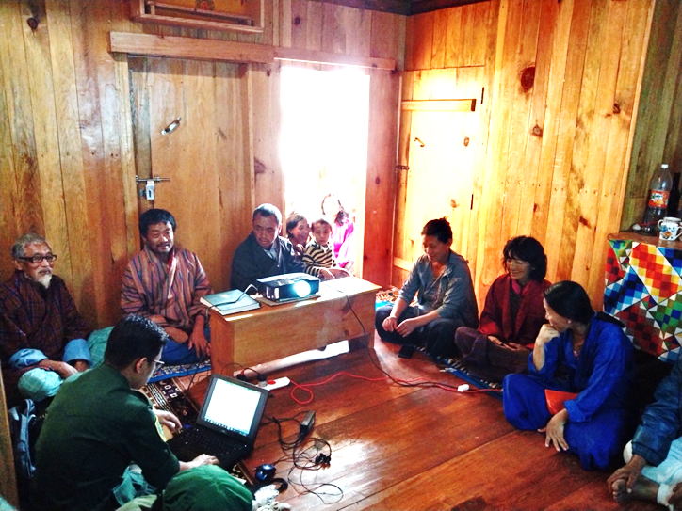
Achievements of the Past Plan
As per the final evaluation carried out by the Divisional Forests Office - Mongar, the Tshangkhar Amla group produced only 109 kgs of dried amla in 2012 and sold to ITMS with support of Regional Agriculture and Marketing Cooperative Office (RAMCO), Mongar. In total the NWFPMG earned Nu.9,701.00 (Nine thousand seven hundred one) only. No expenses have been made for marketing, packaging and processing as all the works has been done through labour contribution.
Figure 1: Final evaluation meeting

Few individual group members are also benefitted from collection and direct sale of Rubia cordifolia to the NWFP buyers, but there are no records maintained on total quantity sold and income generated. The fund generated from the sale of dried Phyllanthus emblica (amla) was utilized for purchase of one truck load of sand and as a transportation charge for development of community Lhakhang. The balance amount of Nu.2,701.00 is available with the Chiwog Tshogpa.
All the NWFPMG members were trained on dried amla processing and packaging for three days. Opportunities such as in country tour were also provided to the executive members and CFMG group for exposure and for knowledge enrichment and exchange learnings.

Description of NWFPs:
Table 1: Brief description of NWFPs for commercial harvesting
NWFP name | Harvesting area(s)  (name) | Parts harvested | Use purpose (traditional & others) | Harvesting season (months) | Estimated quantity that can be collected
Cymbopogon flexuosus (Sorbang) | Half of total area (all Chirpine forest area toward south of the settlement) | Upper part | Local use for treatment of skin diseases | July-September | 50 TL
Rubia cordifolia (Laniru) | Broksibi, Kaptongri, Tshangkhar (251 ha) | Entire plant | Dye- colouring of thread. | November-February | 1000kgs
Phyllanthus emblica (Chorgensay) | Brangsamanma, Nugari, Pilamo, Saipoktor | Fruit | Ritual and traditional medicine | November-February | 500kg
Daphne bholua (Shugushing) | Chaksuzor toth | Bark | Traditional Paper | March to June | Protection only
Paris polyphylla (Thoksampa) | Chaksuzor toth | Rhizome | Ritual and traditional medicine | October-November | Protection only
Bambusa balcooa (Baluka) | Nugari, Pilamo (2 acres) | clump | Basket weaving, fencing, flagpoles | October-February | For domestic use and propagation
Diplazium esculentum (Toenkay) | Sejibi, Okang, Tshaksazor | Fern head | Domestic use (food) | March-September | 200 bundles
Terminalia Chebula  (Aru) | Kaptongri (few numbers) | Fruit | Religious use | November onwards | 50 kgs
Diploknema butyracea  (Pensey) | Nugari, Bangsamanma | Fruit | Oil, food | April-May | 100 kg
Cinnamomum tamala  (Chincha Shing) | Tshaksazor, Yoetsalo | leaves | Spices | March-November | 200 bundles
Thysanolaena latifolia (Soft broom) | Khairidrang | Shoot | Household | December-March | 100 bundles

Harvesting prescriptions for sustainable NWFP harvesting

Table 2: Harvesting prescriptions for sustainable harvesting (As per the interim framework for management and marketing of NWFPs, 2011)
NWFP species | Harvesting prescriptions for sustainable harvesting
Rubia cordifolia (La-nyi-roo) | - Harvest stems of Rubia after seed dispersal, this is mainly from February to April, but might start as early as November in the south of Bhutan, depending on the climate an altitude  - Use sharp sickle or knife for the collection or harvesting of the upper part of the plant.  - Cut the plant at 5 cm above ground level.  - Leave at least 10% of the plants without collecting or harvesting any raw materials from them (these plants shall act as seed plants for natural regeneration).  - Do not collect roots.  - Do not uproot entire plants.
Phyllanthus emblica | - Harvest the fruit by shaking the trees, handpicking and use of poles with hook.  - Do not cut down the trees for the collection of fruits.
Thysanoleana latifolia | - Cut the foliage, inflorescence at 15 cm from the ground  - Do not damage the rhizomes in order to allow natural regeneration
Diplazium spp | - Fiddle heads are collected.
Paris polyphylla | - There are only few individuals which will be protected until next plan period. No collection either for domestic use or for commercial purpose.
Diploknema butyracea | - Collect fruits from the ground or by hand picking  - Or collect by shaking the branches and gathering the fallen fruits  - Collect fruits when fully ripe (fruit turns yellowish when fully ripe)  - Collect about 75% of the fruits and leave at least 25% to allow natural regeneration  - Do not fell tree for the harvesting of fruits  - Do not prune or lop branches for the harvesting of fruits.
Bambusa balcooa | - Individual culms are removed based on horseshoe method of extraction.
Cinnamomum tamala | - The leaves are collected from lower matured branches
Daphne Bholua (Desho) | - Cut the stem at 10 cm above the ground to promote regeneration of shoots through a coppice system. As a rule of thumb this is at the height of a fist with the thumb up. The bark is peeled off after the stem is cut.  - Cut the stem slanting to avoid rotting of the remaining stump  - Cut only stems of more than 3 cm in diameter at 10 cm from the ground; it is recommended to harvest as late as possible because the bark increment increases significantly over the years  - Take care and do not to destroy/ damage remaining stands, seedlings and saplings of Deynap and Deykap while harvesting
Elastostema lineolatum | - Collect plants that are 15cm and above.  - Retain stump of around 3” for sprouting of new shoots.  - Don’t uproot whole plant.  - Shouldn’t cut down trees and create more opening.  - Shouldn’t disturb its catchment area.

Map of the NWFP harvesting areas (based on traditional boundaries, customary practices and availability of NWFP resources)

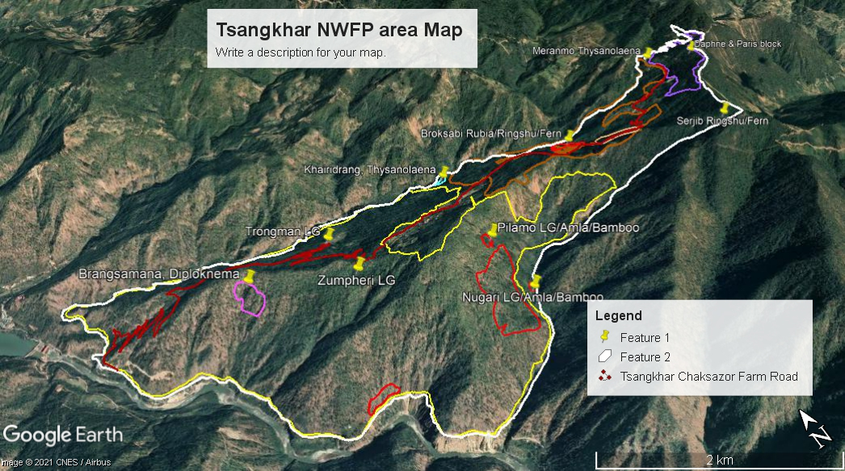

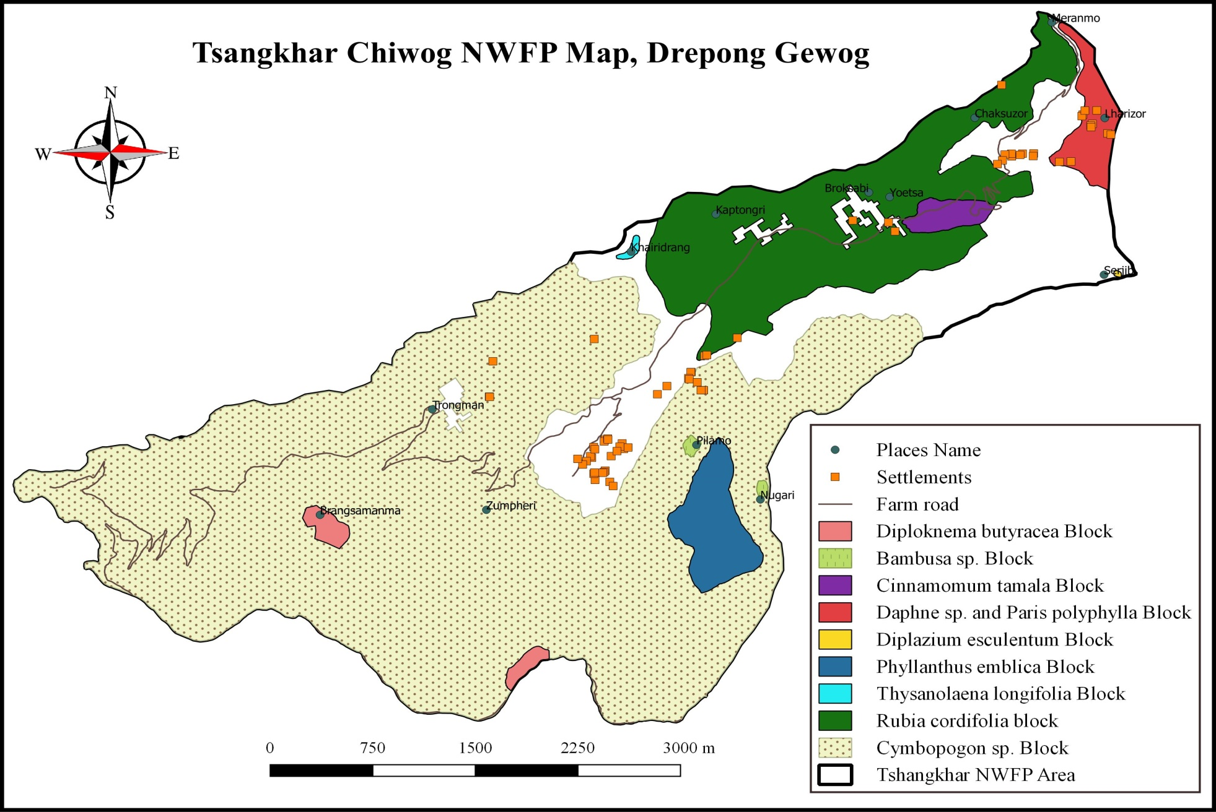

Marketing and sales plan

The executive members will keep track of management plan and harvesting time line. On the onset of harvesting season, the Chairperson will inform the members to collect the forest produce. Accordingly, marketing will be carried out in group although the collection can be done individually. In a year, each household must at least collect one type of product and contribute to group.

Table 3: Marketing and sales plan
NWFP | Potential market | Estimated quantity for sale per season (unit) | Expected price per unit | Total (Nu)
Cymbopogon flexuosus (Sorbang) | International | 50 TL/500 litre | 500 | 250000
Rubia cordifolia (Laniru) | International | 1000kg | 45 | 45000
Phyllanthus emblica (Chorgensay) | Local | 500kg | 90 | 45000
Daphne bholua (Shugushing) | - | Protection only | -
Paris polyphylla (Thoksampa) | - | Protection only | -
Bambusa balcooa (Baluka) | Local | 100 culms/ domestic use only | -
Diplazium esculentum (Toenkay) | Local | 200 bundles | 20 | 4000
Terminalia Chibula  (Aru) | Local | 50 kg | 100 | 5000
Diploknema butyracea  (Pensey) | Local | 100kg | 50 | 5000
Cinnamomum tamala  (Chincha Shing) | Local | 200 bundles | 25 | 5000
Thysanolaena latifolia (Softbroom) | Local | 100 bundles | 150 | 15000

Marketing arrangements
The products will be marketed in the group although collection may be done individually. When the products are ready, it is collected together and an auction shall be organized. If the quantity of products is less, the executive members will facilitate marketing of the product for the group.

Benefits to the members
The members will have to contribute 5% of the total share of benefit he/she obtains from the sale of the product.

Table 4: Financial projection of benefits to the members from NWFP sales (optional)
 |  | Cymbopogon flexuosus | Rubia cordifolia | Zingiber species | Phyllanthus  emblica | Total
1 | Revenues
a | Total quantity (unit) | 500 | 1000 | 8000 | 500
b | Market price (Nu per unit) | 500 | 65 | 25 | 90
c | Total revenues from forest product sales (a*b) | 250000 | 65000 | 200000 | 45000 | 579000
A | Total revenues | 250000 | 65000 | 200000 | 45000 | 579000
2 | Expenses
a | Packaging materials | 10000 | 5000 | 5000 | 10000
b | Royalty | 10000 | 18000 | 16000 | 2000 | 46700
c | Transportation costs | 10000 | 0 | 10000 | 3000 | 28000
d | Compensation fee to executive committee for marketing products | 0 | 0 | 0 | 0 | 0
e | Contribution to community development fund | 12500 | 3250 | 10000 | 2250 | 28950
f | Incidental expenses | 5000 | 2000 | 0 | 0 | 7000
B | Total expenses | 47500 | 28250 | 41000 | 17250 | 143150
C | Total benefit (net-income) of group members (total revenues A – total expenses B) | 202500 | 36750 | 159000 | 27750 | 435850
D | Average income to group members (C/ no of group members) | 4500.00 | 816.67 | 3533.33 | 616.67 | 9685.56
E | Price per unit paid to group members (C/1a) | 405.00 | 36.75 | 19.88 | 55.50

Benefits to the group

Table 5: Financial projection of the benefits to the group, the community development fund (optional)

Sl. No | Particulars | Amount (Nu)
 | Revenues
1 | Membership fees | 22500.00
2 | Contribution to the Community Development Fund (CDF) from sales of product 1 | 28950.00
3 | Fines for absentees in group meeting | 00.00
A | Total revenues | 51450.00
 | Expenses (only include expenses that will be paid from the group funds)
 | Stationeries | 1000.00
 | Refreshment during meeting | 5000.00
B | Total Expenses | 6000.00
C | Balance: Total revenues – total expenses | 45,450.00

PART B: By-laws: Group regulations and norms
1. Members of the NWFP management & marketing group | Village | Number of member households | Geog
 | Tshangkhar | 32 | Drepong
 | Chaksazor | 13 | Drepong
 | Total | 45
Responsibilities and rights of members:
- Collect the NWFP products included in the plan.
- Follow hygienic processing methods.
- All the members shall be responsible for sustainable management of NWFPs.
- All members shall attend to the call of meetings.
- All members to strictly implement the harvesting guidelines.
- Members should actively participate in trainings provided by relevant organisations.
- All members to participate actively in electing committee members and carryout responsibility given by the group members.
- The NWFPs shall be harvested during suitable season as prescribed in management plan.
- When informed by the executive members, the NWFPs group members shall follow and respect their instruction.
- All members shall be vigilant of illegal harvesting of NWFPs by non-members and report to forest office.
- All the group members have right to harvest NWFPs and market as per this plan.
- The NWFPs group members shall ensure not to collect the NWFPs from private registered land in order to avoid inconveniences.
- All members shall share responsibilities and risks.
- The members shall Semi-process the NWFPs individually and maintain the quality.

2. Executive Members
 | Name of the Chairperson: Tobgay, Tshangkhar
2.1 Chairperson | Responsibilities of Coordinator/ Chairperson:  - The chairperson has power to impose fines and penalties if any member does not follow his instruction (meeting, timing).  - Chairperson shall obtain the NWFPs collection permit from forest office before on set of collection season.  - Inform or announce the date and timing of NWFPs collection to each members  - Shall coordinate the NWFPs harvesting.  - Shall contact with the buyer/traders on the required quality of the NWFPs and inform the members accordingly.  - Shall look for the buyers/traders.  - To chair/coordinate all meetings related to this plan.  - Resolve disputes and conflicts among members.  - Take care of overall financial arrangements.  - Attain/participate trainings/workshop/study tour when called.
 | Name of Secretary: Sangay Wangdi, Chaksazor
2.2 Secretary | Responsibilities of Secretary:  - Maintain/keep the sale records of different NWFPs species  - Maintain the minutes of meeting.  - Attend/participate trainings/workshop/study tour when called.  - Assist and officiate the Chairperson whenever needed.  - Keep detail record of NWFPs harvested and submit to Chairperson.  - Shall maintain cash book in absence of Treasurer.
2.3 Treasurer | Name of Treasurer: Sonam Tobgay, Tshangkhar
Responsibilities of Treasurer:
- Maintain cash transaction records.
- Collect membership fees, incentives/compensation fees and deposit in bank
- Look overall financial transaction in collaboration with the chairman and secretary.
- Officiate Secretary
- Keep detail record of NWFPs sale data.
- Present annual expenditure and income of the group to the members during meeting
3. Compensation to the executive committee for marketing | - The group members discussed and decided not to compensate or pay incentives to any executive members for next few years.
4. Membership fee and purpose | - Each member shall contribute Nu.100/- as a membership fees once in a year.  - The membership fees collected shall be deposited in group saving account and use in future development activities of the group.
5. Community development fund and utilization of fund | - The collection of Membership fees, Fines and Penalties and 10% deducted from the sale value will be deposited to Group Account by Treasurer.  - The group members discussed and agreed to utilize fund whenever needed but only after the agreed resolution from the meeting within the group members.

6. New Membership | - Fragmented family members and Zhesaar (New Settlement) opting to join as a member shall be accepted upon payment of equivalent amount to individual share of the total fund raised.

7. Resignations of Members | - Any members intend to withdraw from the group will let to be leaved without any benefit.  - He/she thereafter cannot have rights to market the products included in the signed agreement and from management area.

8. Conflict resolution | - Conflicts or disputes within the NWFP Management Group should be settled as far as possible by the group executive members chaired by Chairperson of the group.  - If the case cannot be resolved, it shall be forwarded to the Gewog Administration via Chiwog Tshogpa.  - In case there is a conflict between the NWFP Group and outsiders, the case shall be forwarded to the Divisional Forest Office and Gewog Administration by the Chairperson.
9. Penalties | - If any member sells the NWFPs directly to the traders without the notice of the group executive committee members shall be penalised as per the FNCRR, 2017.  - In case a member of the NWFP Group violates the harvesting rules as set in this plan, he or she will not be allowed to harvest the NWFPs anymore for the rest of the season and the next season.  - Any members remaining absent in meeting shall be levied a fine of Nu.215/- per meeting.  - In case of absent during work Nu.300/- will be imposed and all collected fines shall be deposited in the group saving account.  - However, during the times of death and sickness consideration will be made but he/she have to inform the Chairperson.  - If any executive members misuse the group fund, he/she has to pay double the amount.

10. Authority of the Department | As per Chapter III, section 155 of FNCRR, 2017, the Department shall:  - Suo moto or on the request by the NWFMG take action against violator of the Act, Rules or Management Plan;  - Inspect, monitor, review the records of and otherwise supervise the activity of the NWFMG; and  - Take action including cancellation of the NWFMG certificate if the NWFMG or any of its members who violate the provision of the Management Plan or any provision under this Chapter

11. Cancellation of NWFP Management Certificate | As per Chapter III, section 156, 157 & 158 of FNCRR, 2017:  - The certificate shall be cancelled, if the performance of NWFMG is not as per prescriptions of the approved management plan or the sustainability of the resource is not ensured  - In the event the members of the NWFMG decide to cancel NWFP Management certificate in accordance with this Rules, the NWFP Management Certificate shall be deemed cancelled on the date of such decision being notified to CFO in writing and the NWFMG shall surrender the Certificate to the Department  - The CFO shall have the right to enquire about the reason for such cancellation to ensure that no offence has been committed and shall notify the NWFMG on the cancellation of the certificate.

12. Annexures

Annexure I: NWFP Group Membership List

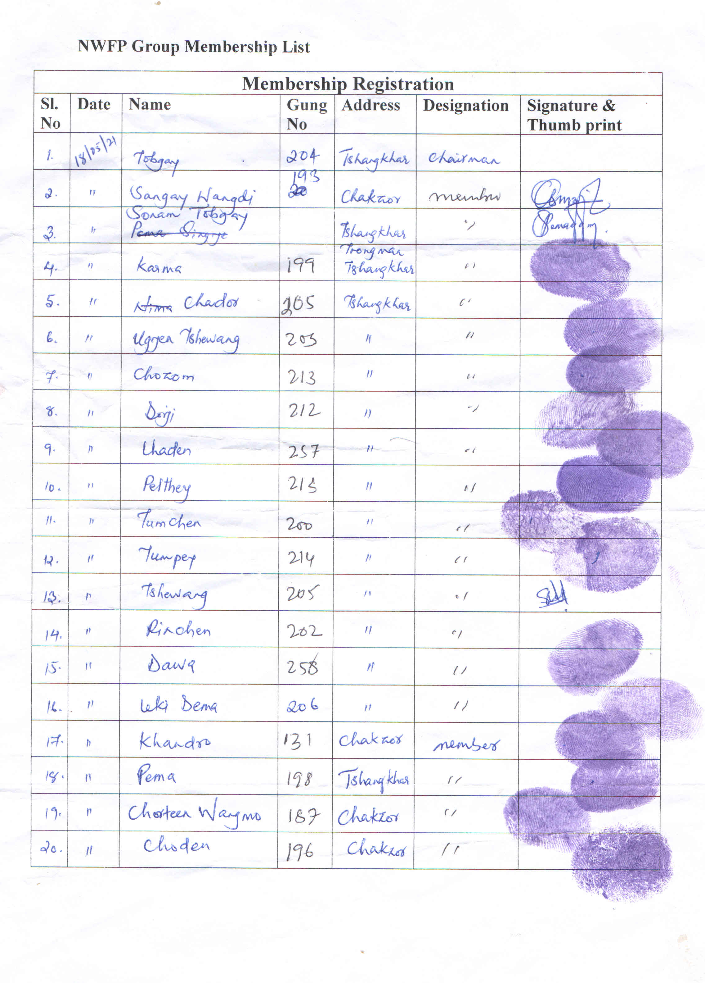

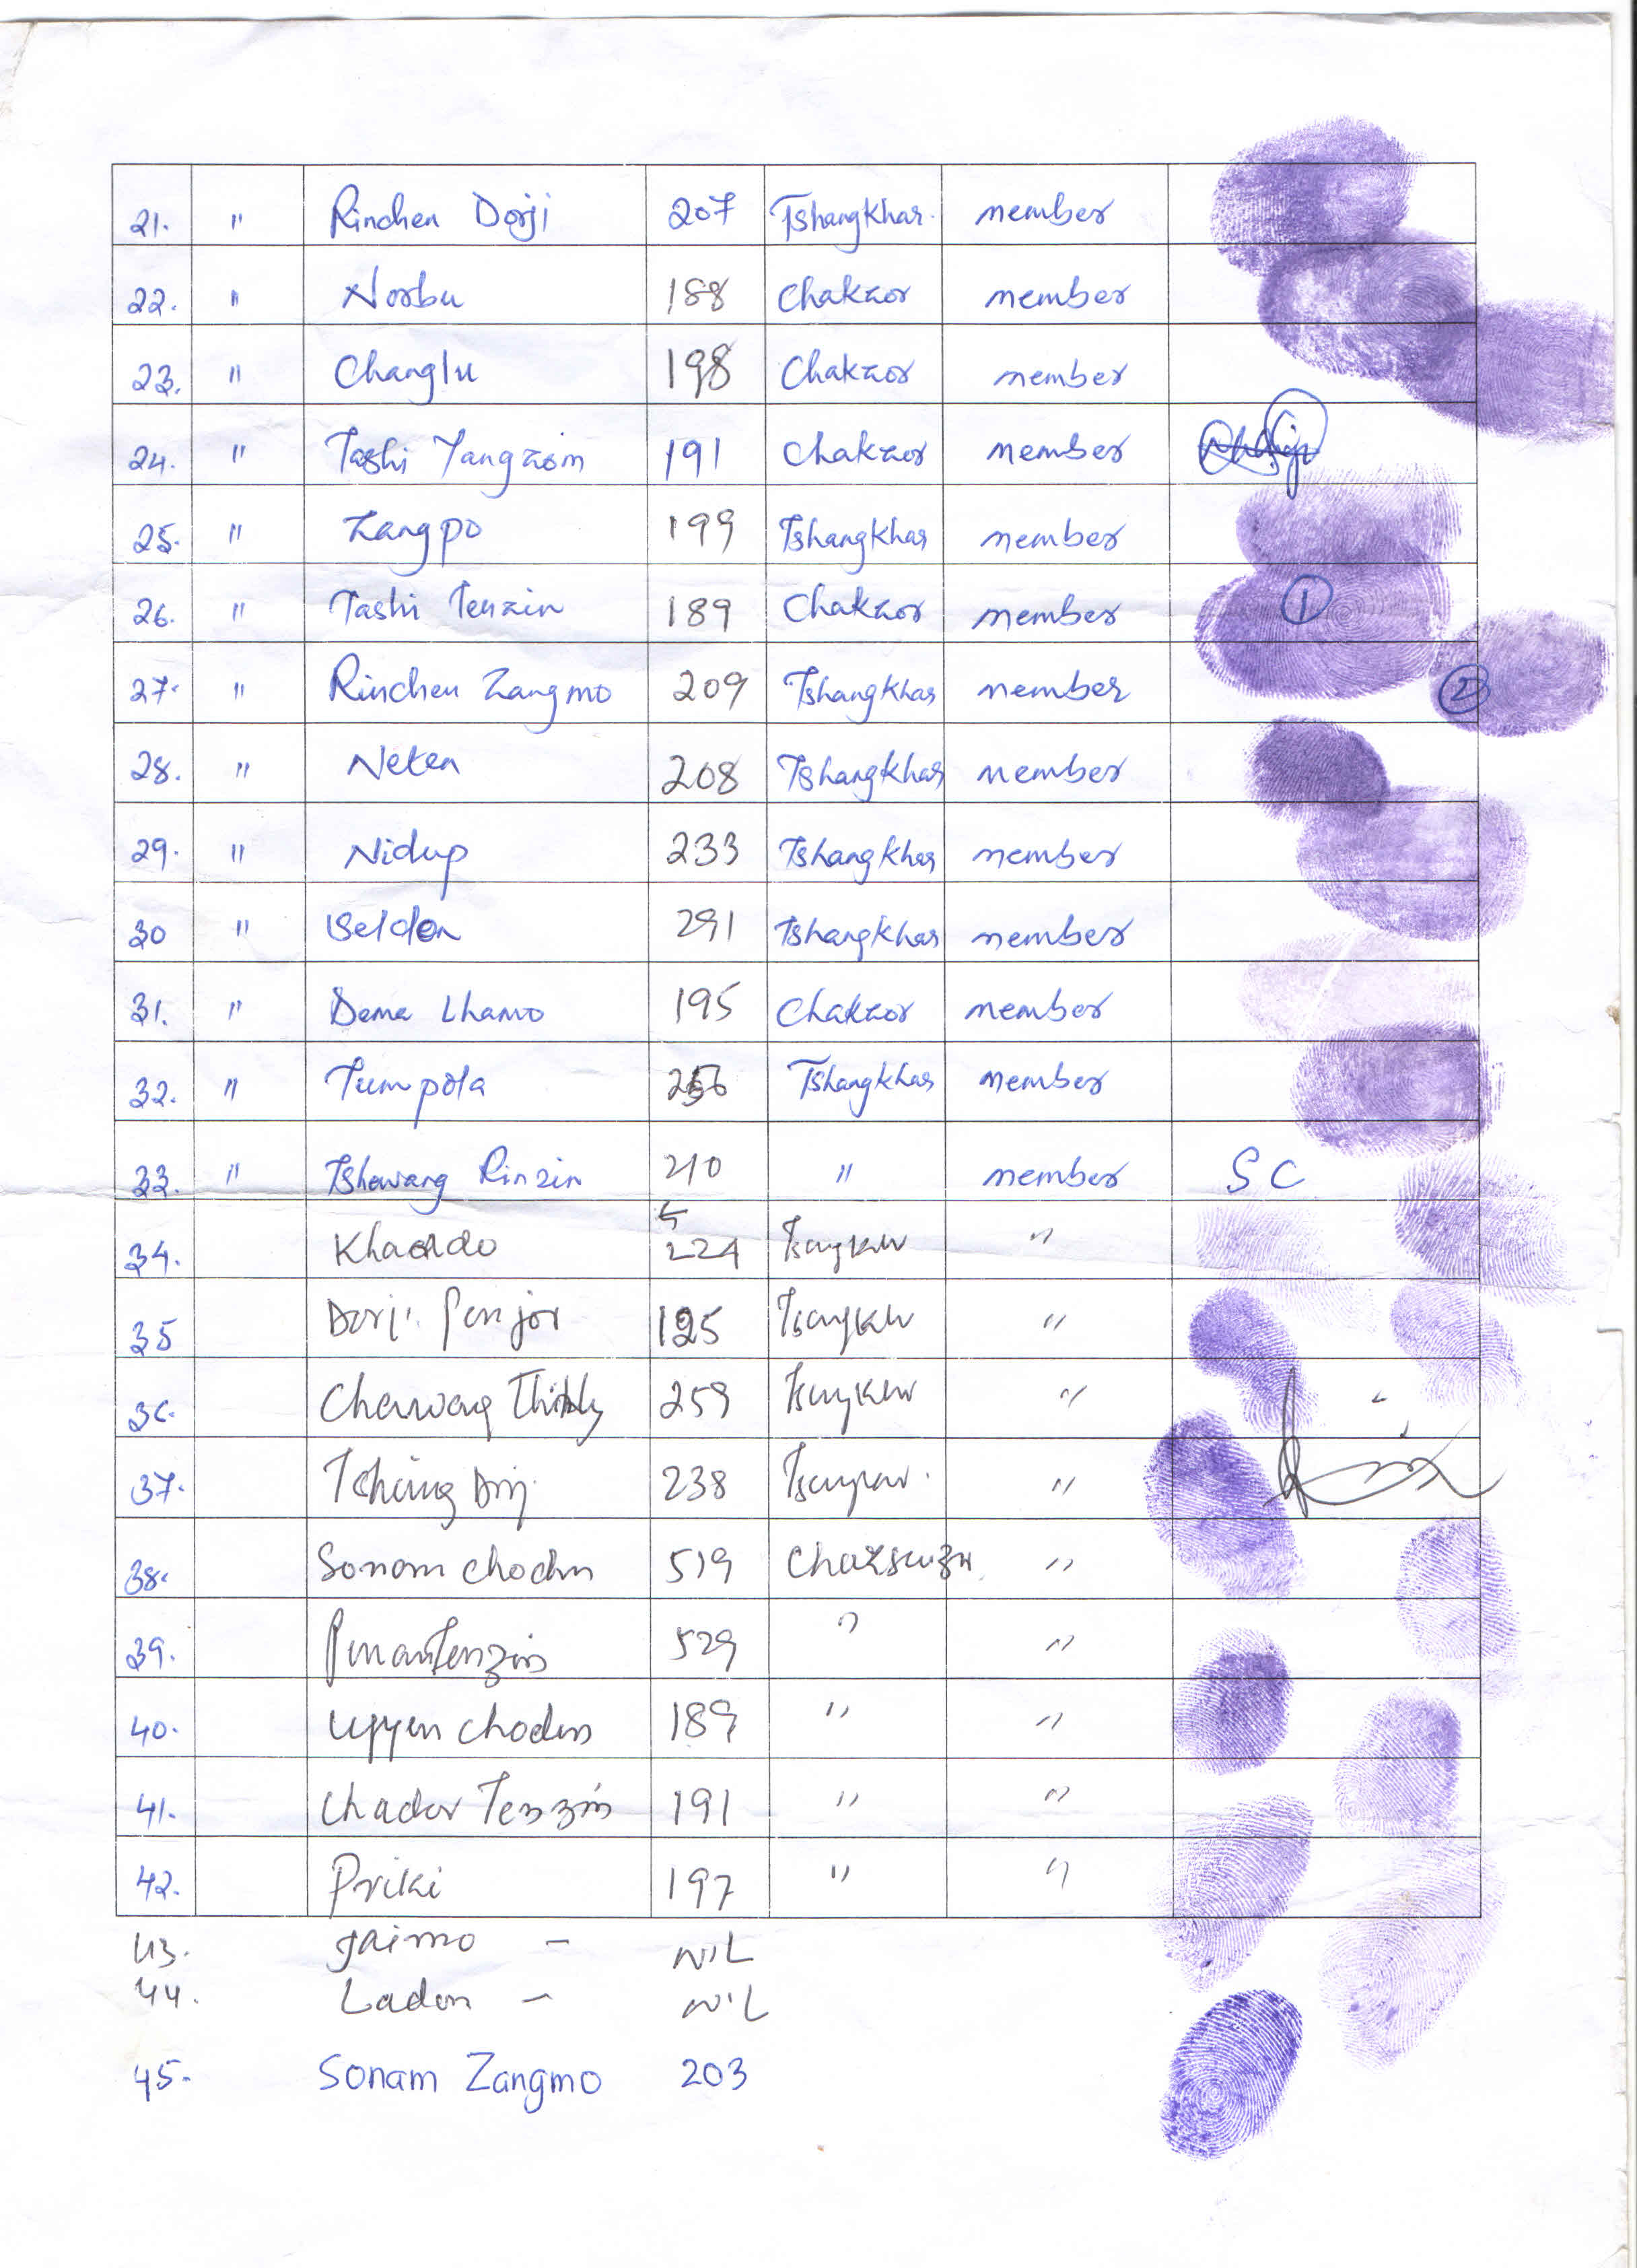

Annexure II: List of NWFPs to be collected by the group member

Sl. No. | Local Name of NWFPs | Scientific name of NWFPs
1 | Sorbang | Cymbopogon flexuosus
2 | Khuisa | Zingiber species
3 | Laniru | Rubia cordifolia
4 | Chorgensay | Phyllanthus emblica
5 | Shugushing | Daphne bholua
6 | Thoksampa | Paris polyphylla
7 | Baluka | Bamboosa balcooa
8 | Dawai | Diplazium esculentum
9 | Aru | Terminalia Chebula
10 | Pinsey | Diploknema butyracea
11 | Chincha Shing | Cinnamomum tamala
12 | Softbroom | Thysanolaena latifolia
13 | Saitsam (Sharchop) | Wallichia oblongata

